This must be in PDF format.

ISAD251 Database Assignment – Thomas Hinton - 10612662

Application Design Document

storyboard to illustrate your application.

Version 1

Draw.io- (From paper Form to digital)

Of course, this wasn’t the final version of the website, to make sure I didn’t miss anything essential I had someone look at the current version of the story board. From this I was able to Identify The good parts and some flaws that I had with the design so with that Knowledge I designed a storyboard that would be better for the user.

**Peer Review Story Board**

Peer Review carried out by: Chloe Thorne Date:21/10/2019

Task conducted:

Adding an item to the basket

Was the task easy to carry out? (If no or not really, please say why)

Yes

Did you encounter any errors? (If yes, please explain what)

No errors encountered.

Did the author have to explain how to use anything? (If yes, what?)

How to navigate – how it will differentiate from customer to admin.

Did you gain any inspiration for your own practice? (If so what?)

A box saying which items have been added to the basket on the side of the menu page.

What constructive advice would you give the author for presenting their work/code in future?

Add a page for the admin to view the customer’s orders.

Story Board 2

Version 2

What Changed and why and what I would I added if I had more time

UML diagrams to illustrate the architecture of your application and how the server-side classes are constructed and their interaction.

Activity Diagram

Entity-Relationship diagram that illustrates how your database has been constructed.

No log in so no customer or admin tables needed, used tables number and customer names so each order can be assiosated with a customer, customer will be asked to insert there first name and tables when they order

Class Diagrams

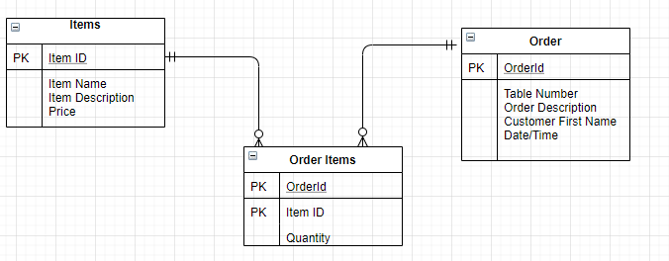

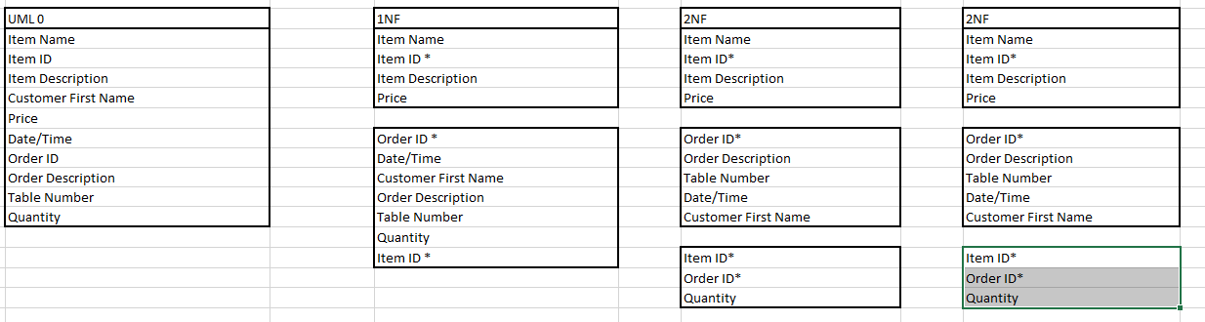

.

Document any settings and images.

Provide evidence that you have tested your web application using the Web Accessbility Initiative (WAI) guidelines with a commentary about what you would change and why.

Include a list of the feedback acquired from the Demo sessions indicating what you changed and what you would change if you had more time.

Provide the URL’s for your API middleware, your hosted web pages and your GitHub repo.